TITLE: BUT I DON’T NEED a SHOW LABRADOR!

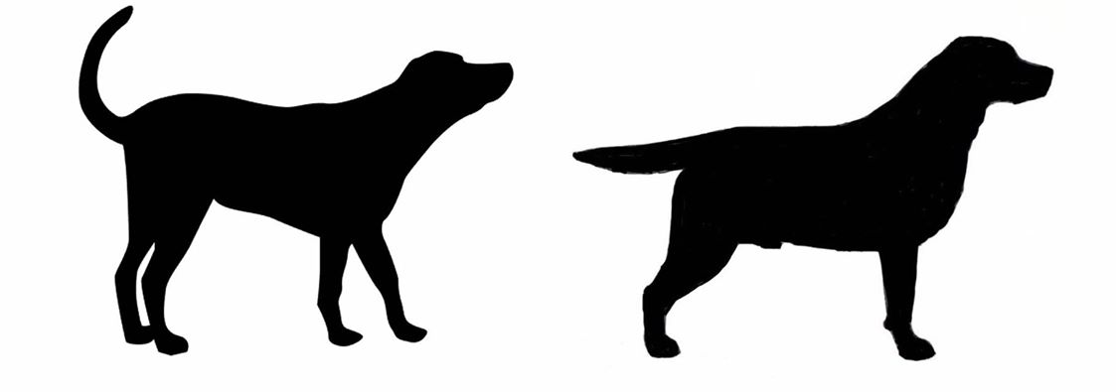

Permission to share if full credit is included.
But I Don’t Need a Show Labrador!
(Originally Written about Newfoundland Dogs by Terri Lewin Gilbert)
Adapted for the Labrador Retriever by Margaret Wilson.
Many thanks to Terri for allowing me to adapt her wonderful article.

Why do people recommend choosing a breeder who shows and titles their dogs to folks who are just looking for a pet and have no interest in showing? Why should breeding to breed standard be important to a pet home? Does it seem excessive, or “snobby”? It’s not, and here’s why.
Dog shows are a means of evaluating dogs against the breed standard, to evaluate soundness, movement/gait, type, and temperament.
Soundness: The state of physical and mental health when all organs and faculties are functioning properly, each in its rightful relation to each other.
Type: Breed type encompasses appearance, character, condition, bone structure, temperament, and movement; "breed type is all these things." Breed type also includes a character specific to each breed, a combination of behaviour, temperament and carriage that demonstrate an essence of the breed.
Size – The height at the withers for a dog is 22-1/2 to 24-1/2 inches; for a bitch is 21-1/2 to 23-1/2 inches. Any variance greater than 1/2 inch above or below these heights is a disqualification. Approximate weight of dogs and bitches in working condition: dogs 65 to 80 pounds; bitches 55 to 70 pounds.
Proportion – Short-coupled; length from the point of the shoulder to the point of the rump is equal to or slightly longer than the distance from the withers to the ground. Distance from the elbow to the ground should be equal to one half of the height at the withers. The brisket should extend to the elbows, but not perceptibly deeper. The body must be of sufficient length to permit a straight, free and efficient stride; but the dog should never appear low and long or tall and leggy in outline.

Substance – Substance and bone proportionate to the overall dog. Light,”weedy” individuals are definitely incorrect; equally objectionable are cloddy lumbering specimens.
Gait: The gait of a dog is its quality of movement. You want to see ease of movement, unimpaired by illness or poor structure.
Temperament: The general attitude a dog has towards other animals and people. From the AKC Labrador Retriever Breed Standard: “True Labrador Retriever temperament is as much a hallmark of the breed as the “otter” tail. The ideal disposition is one of a kindly, outgoing, tractable nature; eager to please and non-aggressive towards man or animal. The Labrador has much that appeals to people; his gentle ways, intelligence and adaptability make him an ideal dog. Aggressiveness towards humans or other animals, or any evidence of shyness in an adult should be severely penalized.”
Color: The Labrador Retriever coat colors are black, yellow and chocolate. Any other color or a combination of colors is a disqualification. A small white spot on the chest is permissible, but not desirable. White hairs from aging or scarring are not to be misinterpreted as brindling. Dilute colors are a breed disqualification
Black – Blacks are all black. A black with brindle markings or a black with tan markings is a disqualification.
Yellow – Yellows may range in color from fox-red to light cream, with variations in shading on the ears, back, and underparts of the dog.
Chocolate – Chocolates can vary in shade from light to dark chocolate. Chocolate with brindle or tan markings is a disqualification.
So. That’s a very basic intro to what goes on at a show... why does this matter? You want a pet, a companion, not a show dog, right? Well, you chose Labradors for a reason. You’ve done your research, and have read that they’re great with kids and other animals, they’re gentle, biddable, stable, and not aggressive, they make excellent companions and love spending time with their people. That their good and kind nature predisposes many Labradors to be excellent therapy and service dogs. That they are a strongly built dog of medium-size, short-coupled, possessing a sound, athletic, and well-balanced conformation, with the character and quality to win in the show ring; and the temperament to be a family companion which makes them admirably suited to a variety of lifestyles and occupations, and which has made them the world’s most popular breed for good reason.

Ethical, responsible breeders seek to preserve and protect these definitive and positive characteristics and not deliberately breed for disqualifying conditions which are alien and detrimental to the breed.
An aggressive dog is no joke, and an oversized, powerful aggressive dog even less so. Aggression can run in lines. Wouldn’t it be difficult to show an aggressive, reactive, fearful, or excessively shy Labrador? Do you want to take the gamble and trust someone about their dog’s history, or would you rather buy from someone who has taken their dogs into the ring and had the dog’s temperament proven over and over, consistently?
What about type and structure? How the dog is put together, able to move freely and comfortably? Would you rather buy from someone who has proven publicly, over time, that the dog they’re breeding can move well, free of limp, or a structural problem? Or just trust someone who has no interest in proving their dogs? It’s your puppy’s quality of life and comfort (as well as your wallet) that’s at stake.
Not every dog in a well-bred litter is going to be show quality- there will ALWAYS be pet-quality puppies. Well-bred, but maybe with a slight imperfection, and those are the puppies placed in pet homes. You don’t have to want a show-quality puppy to get a well-bred puppy!
Show quality litters are bred by people who actually show their dogs, and these breeders are the ones who are most qualified to determine what is, and what is not a show quality puppy. Having some titled ancestors in a pedigree, even two generations back, is no indication of being show quality.
Here’s the bottom line.... every day, Lab rescue is seeing more poorly bred aggressive Labradors and Lab mixes. Labradors in pain because they were poorly bred. Labs requiring extensive vet care, expensive surgery, and serious behavior modification. People having to remand their dogs to breed rescue because they can’t manage the dog, fear the dog, or found out the dog needs costly vet care they can’t afford.
This is not about being snobby, being elitist, thinking that one dog is “better” than another, it’s about ensuring you get a puppy that acts and looks like the breed you fell in love with. It’s about ensuring that all Lab puppies have the best start in life, and will grow into a loving family member. It’s about loving our breed enough to want to see everything that’s good about them preserved for future generations to enjoy. If you want a healthy dog, with a properly sweet temperament, choose your breeder wisely

